5, Warning Note
The bombarder neon transforme secondary output voltage up to 15KV, it may cause the risk of human body much greater than the normal neon. Therefore, except the insulation materials, when make the pipe exhausting system table, shall use wooden construction instead of metal materials, and the bombarder neon transformer shall have a good grounding.
].
6, Special Attention
When use the bombarder neon transformer, must ensure the the integrity of output high voltage cable , and never be allowed to use damaged or breach cable. have damaged.

High voltage cable pass through the console, there must have protecting sleeve packed. Strictly eliminate the phenomenon of high-voltage output terminal to be grounded (commonly known as Ground).

Our products have been strictly tested and inspected before shipment, really welcome any enqury, order to us.

Shanghai Yiya Electricity Equipment Co., Ltd.
No. 8910 Hunan Road, Nanhui,Pudong New Distrit, Shanghai, China.
Tel： 86（021）58189351 58189353
Fax： 86（021）58189352
P.S Code：201314
Web：www.sh-yiya.com
Email: dirving@163.com

Bombarder Neon Transformer

Operation Instruction



Shanghai Yiya Electricity Equipment Co., Ltd.
www.sh-yiya.com

TH Bombarder Neon Transformer
Operation Instruction

Our company is a specialized manufacturer of neon transformer, we has a very long history in manufacturing bombarder neon transformer. Which features great power, firm structure and realiable quality.

1, Scope of application
This bombarder neon transformer is one of the most indispensable equipment to make neon , and its main role is to clear and remove the impurities which adsorbed in the neon tube.

2, Working Principle
With the bombarding of the bombarder neon transformer’s output high voltage and high current to the neon tube, then discharge the gas inside the tube, when current flows through the gas, the themosterese will heat the tube then to be deflated. this time, the positive ions are formed when discharging and come to bombard to the electrode, the electrode will be heated and deflated.. Through the bombardment and degassing, the impurities adsorbed in neon tube electrodes will be released, as a result, to achieve the purpose of clearing the neon tube.
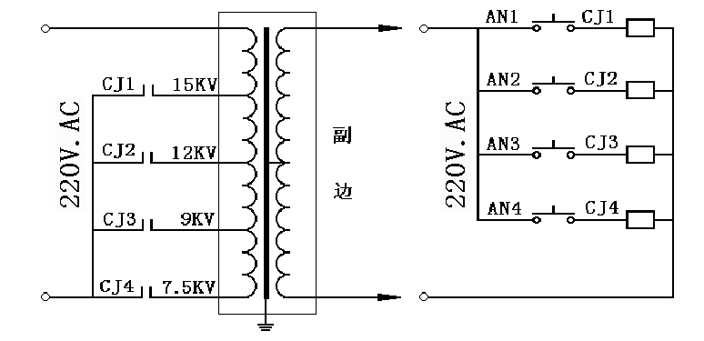

Work Diagram
Control Diagram
Electrical principle chart

3, Use Methods
Connect the rated voltage to the transformer’s input terminal, then use the high-voltage cable to connect the high voltage output terminal and the tube which are ready for bombardment, Plug in the power switch, then select the corresponding voltage lever and press the related button, the bombarder neon transformer come to start the bombardment to the tube.

4, Technical Specifications

Model | Rated Input Voltage(V) | Rated Frequency  (Hz) | Input Current (A) | Output Voltage (KV) | Output Current (mA) | Capacity  (KVA) | Weight  (KG)
TH075 | 220 | 50 | 40  25  15  10 | 15  12  9  7.5 | 500 | 7.5 | 65
TH100 | 220 | 50 | 45  23  13  10 | 15  12  9  7.5 | 660 | 10 | 65
TH150 | 220 | 50 | 68  49  31  17 | 18  15  12  9 | 1000 | 15 | 80
TH210 | 220 | 50 | 88  50  28  24 | 15  12  9  7.5 | 1400 | 21 | 97
Remark: 380V Rated input voltage is optional.

